Nick Layman

Project 1 – Business Card

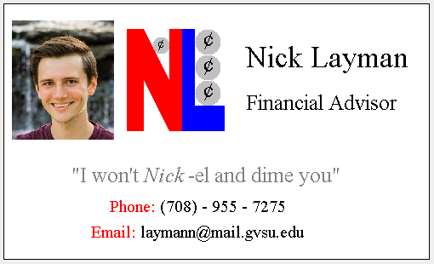

"I pledge that this work is entirely mine, and mine alone (except for any code provided by my instructor).”

X_________________________________

I spent 6 hours and 25 minutes working on this project from September 12 to September 14, 2018 thinking of a design writing the code, fixing errors, changing things to look better, reading the Java API, making the code more elegant, and making this printed document.

Source Code:

import javax.swing.*;

import java.awt.*;

import java.awt.image.*;

import javax.imageio.*;

import java.io.*;

/**

* Making a business card.

*

* @author (Nick Layman)

* @version (9/14/2018)

*/

public class Card extends JPanel{

public static void main(String[] a) {

JFrame f = new JFrame();

f.setContentPane(new Card());

f.setSize(550, 385);

f.setVisible(true);

}

public void paintComponent(Graphics g){

int outlinex = 10; // left of card outline

int outliney = 10; // top of card outline

int namex = outlinex + 285; // left of name

int namey = outliney + 75; // bottom of name

int jobNamex = namex; // left of job name

int jobNamey = namey + 50; // bottom of job name

int mottox = outlinex + 80; // left of motto

int mottoy = outliney + 210; // bottom of motto

int phonex = mottox + 45; // left of phone

int phoney = mottoy + 35; // bottom of phone

int emailx = phonex - 22; // left of email

int emaily = phoney + 30; // bottom of email

int logox = 155; // left of logo

int logoy = 40; // top of logo

int picturex = 20; // left of picture

int picturey = 30; // top of picture

// define all used fonts

Font nameFont = new Font("serif", Font.PLAIN, 35);

Font companyFont = new Font("serif", Font.PLAIN, 25);

Font mottoFont = new Font("serif", Font.PLAIN, 25);

Font mottoFontPun = new Font("serif", Font.ITALIC, 25);

Font contactFont = new Font("serif", Font.PLAIN, 20);

Font coinFont1 = new Font ("serif", Font.PLAIN, 15);

Font coinFont2 = new Font ("serif", Font.PLAIN, 25);

// this statement required

super.paintComponent(g);

// draw card outline

g.setColor(Color.white);

g.fillRect(outlinex, outliney, 500, 300);

g.setColor(Color.black);

g.drawRect(outlinex, outliney, 500, 300);

// display my name

g.setColor(Color.black);

g.setFont(nameFont);

g.drawString("Nick Layman", namex, namey);

// display company name

g.setColor(Color.black);

g.setFont(companyFont);

g.drawString("Financial Advisor", jobNamex, jobNamey);

// display my motto and pun

g.setColor(Color.gray);

g.setFont(mottoFont);

g.drawString("\"I won't", mottox, mottoy);

g.setFont(mottoFontPun);

g.drawString("Nick", mottox + 85, mottoy);

g.setFont(mottoFont);

g.drawString("-el and dime you\"", mottox + 137, mottoy);

// display contact information

g.setColor(Color.red);

g.setFont(contactFont);

g.drawString("Phone: ", phonex, phoney);

g.setColor(Color.black);

g.drawString("(708) - 955 - 7275", phonex + 59, phoney);

g.setColor(Color.red);

g.drawString("Email: ", emailx, emaily);

g.setColor(Color.black);

g.drawString("laymann@mail.gvsu.edu", emailx + 58, emaily);

// define logo letter coordinates

int[] letternx =

{logox, logox, logox + 20, logox + 50,

logox + 50, logox + 65, logox + 65, logox + 50,

logox + 20, logox + 20, logox};

int[] letterny =

{logoy + 120, logoy, logoy, logoy + 60,

logoy, logoy, logoy + 120, logoy + 120,

logoy + 60, logoy + 120, logoy + 120};

int[] letterlx =

{logox + 65, logox + 80, logox + 80, logox + 115,

logox + 115, logox + 65, logox + 65};

int[] letterly =

{logoy, logoy, logoy + 90, logoy + 90,

logoy + 120, logoy + 120, logoy};

// display NL of logo

g.setColor(Color.red);

g.fillPolygon(letternx, letterny, 11);

g.setColor(Color.blue);

g.fillPolygon(letterlx, letterly, 7);

// display coins of logo

g.setColor(Color.lightGray);

g.fillOval(logox + 30, logoy + 9, 20, 20);

g.fillOval(logox + 80, logoy + 60, 30, 30);

g.fillOval(logox + 80, logoy + 30, 30, 30);

g.fillOval(logox + 80, logoy, 30, 30);

g.setColor(Color.black);

g.setFont(coinFont1);

g.drawString("¢", logox + 36, logoy + 22);

g.setFont(coinFont2);

g.drawString("¢", logox + 90, logoy + 20);

g.drawString("¢", logox + 90, logoy + 50);

g.drawString("¢", logox + 90, logoy + 80);

// display picture

BufferedImage photo = null;

try {

File file = new File("business picture.jpg");

photo = ImageIO.read(file);

} catch (IOException e){

g.drawString("Problem reading the file", 100, 100);

}

g.drawImage(photo, picturex, picturey, 120, 140, null);

}

}